**Curriculum Policy**

**The Haven School**



|  |  |  |
| --- | --- | --- |
| **Approved by:**  Jane Spensley |  | **Date: Feb 2020** |
| **Last reviewed on:** Oct 23 | **Next Review:** Oct 25 | |
|  |  | |

**The Haven School Curriculum Policy**

**Contents:**

* 1. Curriculum Intent
* 2. Curriculum Overview
* 3. The Haven school social and emotional curriculum
* 4.Roles and responsibilities

**Appendices**

1. How we work with young people at the Haven School
2. Student pathways

(Please also refer to the Haven School’s Teaching and Learning Policy and Online Learning Policy)

1. **The Haven School Curriculum Intent**

Our curriculum is designed to inspire pupils to re-engage with education so they can develop the knowledge and skills they need for life beyond The Haven, as well as the resilience to tackle the challenges that life may bring.

As a Trauma Informed and Attachment Aware school, we support students to manage their stress and anxiety in a safe and therapeutic environment, helping them to develop personal skills as well as achieve their academic potential.

At The Haven, we believe in delivering a broad and balanced curriculum so that students have experience of a wide range of subjects for as long as possible, as well as enrichment opportunities to promote engagement, build relationships and encourage independence. Independent learning sessions are built into the curriculum to allow students to discover and pursue their own particular interests and passions as well as developing literacy skills. A combination of teaching skills and knowledge, the academic with the creative, and the challenge with the accessible, ensures our curriculum is both engaging and balanced. Literacy is an essential component of the Haven curriculum and staff ensure that reading, writing, speaking and listening are taught across all subjects.

The programme that students follow at The Haven reflects their needs and is informed by their Education, Health and Care Plan (EHCP). Each student has an Individual Learning Plan (ILP) and follows a Haven Star assessment pathway that allows them to achieve individual goals and make progress towards the outcomes on their EHCP.

1. **Curriculum Overview**

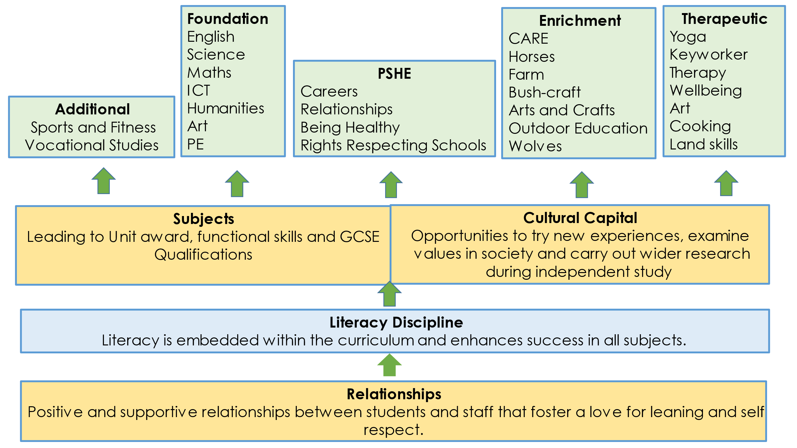

**Personal, Social, Health and Economic education (PSHE)**

PSHE threads through the whole curriculum at The Haven. All students are encouraged to access this through a variety of means including timetabled lessons, form time, assemblies and Key Worker sessions. The PSHE subject content is differentiated between key-stage 3, year 10 and year 11. In addition to this, our Rights Respecting schools programme runs throughout the curriculum and all pupils complete a personal careers pathway document throughout their journey at the Haven (Please refer to our PSHE policy and Careers Policy for further information.)

**Foundation Subjects/Accredited courses**

English, Maths, Science, PE, Art, Humanities and Computing are fundamental core subjects which Key Stage 3 and 4 study as part of their bespoke programme.

All students at The Haven work towards nationally standardised summative assessments. Depending on ability these are at Functional Skills Level and/or GCSE Level. GCSEs currently being offered in-house are English, Maths, Chemistry, Biology and Geography and PE BTEC. In Science, students can also do entry level qualifications and students can achieve a range of AQA Unit Awards across the curriculum to help promote engagement and build self-esteem.

**Cultural Capital**

The curriculum is enriched with additional subjects such as Crafts, Animal care and Cooking, and also offsite activities such as land skills, farming and outdoor education. We value experiences outside of the classroom which are used to strengthen relationships and enhance learning. Some examples are of this are inter -school tournaments, visits to museums, National Trust properties, theatre trips and the careers fairs.

**Literacy Discipline**

Staff receive regular training, and share good practice to ensure they are teaching literacy within their subject area. This helps pupils to learn how to write like a scientist, read like a mathematician and speak like a historian! These skills are essential for success at GCSE and allow pupils to become more independent. In addition our reading software ‘Lexplore’ helps us to track progress and deliver intervention to pupils who need further support.

**Sixth Form Curriculum-**

All 6th form students following our core pathway will study for a Vocational BTEC qualification which enables them to prepare themselves for the wider world and includes important skills for many types of employment and opportunities for work experience. Some students will choose to take additional GCSE subjects dependent on their specific needs.

1. **The Haven School – Social and Emotional Curriculum**

As a school specialising in social, emotional and mental health needs we believe that this area of our curriculum is integral to the success of our pupils. We see our daily processes and procedures and the relationships that are formed within school as a vital part of this curriculum.

Daily Procedures

These should assist a pupil to come to school free from anxiety so that they are able to focus on learning. Pupils are received into school each morning with a warm greeting and social conversation with staff. There is a breakfast club available from 8.45 until 9.05 where pupils can have tea and toast and socialise with other pupils and staff. Break and lunch times are other opportunities to socialise and board games, as well as chess and table tennis, are available to promote easy relationship building.

Keyworker

All pupils have weekly individual mentoring sessions with their keyworker as part of their individual learning plan. During these sessions, pupils are encouraged to reflect on their progress and air any issues of concern. Time is spent looking at career paths and work experience, learning plans and relationship development. These sessions are then communicated with parents on a weekly basis via a keyworker phone-call or email home.

Emotional Support

We have a chartered clinical psychologist in school one day per week. This gives plenty of time for her to work with pupils and, when desired, parents and carers. Pupils will more readily engage with the psychologist when they see her regularly and as part of the school staff. She is highly skilled at encouraging reluctant young people to discuss their thoughts and feelings and help them develop resilience.

There is a full time well-being and family support liaison in school who delivers regular wellbeing and skill-building sessions to pupils. She offers support to parents, carers and families on an individual basis; often engaging in outreach work to promote and increase attendance and put interventions in place.

# Roles and responsibilities

# The governing board

The governing board will monitor the effectiveness of this policy and hold the head teacher to account for its implementation.

The governing board will also ensure that:

* A robust framework is in place for setting curriculum priorities and aspirational targets
* The school is complying with its funding agreement and teaching a "broad and balanced curriculum" which includes English, maths, science, PSHE and religious education.
* All courses provided for pupils below the age of 19 that lead to qualifications, such as GCSEs and A-levels, are approved by the secretary of state
* The school implements the relevant statutory assessment arrangements

# Monitoring arrangements

The senior leadership team monitor the way subjects are taught throughout the school by:

* Review of Assessment data (progress meetings where appropriate)
* Regular departmental/exams meetings
* Planning scrutinies (planning submitted half termly)
* Learning Walks and Book scrutinies
* Student Voice

**Appendices A.**

How we work with young people at The Haven School

The vast majority of our pupils want to behave well, learn successfully and thrive. However, their mental ill health or emotional distress interferes with this.

We use a medical model to support our pupils to improved health.  This can prove more complex than when helping someone get better from a physical illness because mental ill health does not necessarily make linear progress.  Sometimes we see great improvement which can be sustained for weeks or even months but then an event can occur which knocks the pupil off course again.  For our young people who are looked after, this could be a change of home placement; for children who have suffered trauma or family breakdown there are multiple scenarios that can occur – the return of a long lost family member, the disappearance of a parent or another event that retriggers the trauma etc. Sometimes there is no obvious reason for the return of emotional instability. However, pupils need intensive support at these times. This is where the importance of positive relationships with staff, built up over time, can have a big impact. A pupil will often confide in a trusted adult and, by talking through their trauma, make steps towards improvement.

At these times it may be necessary to modify the programme that the pupil is following and adaptations are made to their timetable, allowing more time for calming and reducing either academic or social pressure. We are experienced in monitoring and managing emotional distress and mental ill health and work with the family and other professionals to agree steps which support the young person. Our records prove that this approach works. Some pupils who have not been to school for years remain on roll at The Haven and achieve success in examinations and move on to other educational destinations.

As with other forms of ill health, when a pupil is suffering from emotional distress, they may need time out of school to access medical appointments, or to recover enough to be able to re-engage with school. This can impact on their attendance. However, we work closely with all professionals and parents/carers to ensure pupils are back in school as soon as they are ready and able to manage. When a pupil has suffered significant distress, we may use the principle of gradual exposure to re-integrate them back into the school. This model has been successful with many of our students. Timetables are reviewed weekly, with the aim being for them to be in school, as close to full time as possible, as soon as they are able.

We do not underestimate the effort it takes for some young people to navigate their way through the school system. Emotional distress and associated issues of low self-esteem, low mood, fear of failure etc. are very hard to live with and manage. Our staff are very aware of this and our training and procedures ensure that all our young people are very well supported at The Haven.

**Appendices B:**

**The Haven School- Student Pathways**

The diagram below represents how staff use professional judgment about which pathway is the best fit for a student. A student does not need to tick all of the descriptors; a best fit model is used to assign students to the most appropriate pathway. Evidence from EHCP, discussions with parents/carers and the school’s clinical psychologist all help inform where a student is best placed. The aim is for all students to move to the main cohort pathway as soon as possible. However, for some students with the most complex needs this may not be possible. There may be situations where a student moves from the main cohort pathway to the engagement pathway so that they can be supported in a more therapeutic way. Examples of when this might happen maybe when a care placement breaks down or there is a change in family circumstances or a deterioration in the mental/physical health of the child.

All students on the engagement pathway have an integration plan that is reviewed weekly by SLT and monthly with all stakeholders.

**Engagement Pathway-Description**

**Long term low attendance. Significant challenging domestic circumstances. Trauma or mental health diagnosis having a significant impact of learning. Historic low prior attainment, significant gaps in learning potentially aggressive and violent behaviour. Difficulty in making positive relationships and working in even small groups.**

Main Cohort Pathway-**Description**

**Some history of low attendance and challenging domestic issues. Trauma or mental health diagnosis having an impact on learning. In general, lower than expected academic progress has been made and there are gaps in learning. Child is starting to work in a group and displays some resilience**

**Main Cohort Pathway**

**Increase attendance/improve engagement and participation in lessons/develop and sustain wider relationships**

**Engagement Pathway Priorities**

**Improve attendance/develop relationships with key adults/develop simple learning behaviours**

**What is effective progress?**

**Making progress in one key area: attendance, SEMH or academic**

**What is effective progress?**

**Making progress in two or more key areas: attendance, SEMH or academic**

**Expected KS 4 Outcomes**

**Min of 2 appropriate qualifications that supports progression to post 16 and beyond**

**Expected KS 4 Outcomes**

**Min of 4 appropriate qualifications to include Maths and English that supports progression to post 16 and beyond**

**Progression**

**To main cohort pathway or specialist supported post 16 provision**

**Curriculum implementation**

**Progression**

**Chosen Post 16 Provision**