**Safeguarding Newsletter**

**July 2024**

**If you have a concern about the safety or welfare of any child at our school, please speak to:**

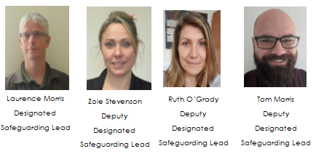

**We want everyone to enjoy a happy and safe summer. Please read the document from Staffordshire Police and Fire Services sent along with this email.**

**Transition Advice**

For any young people moving to new schools/colleges, Childline have produced some useful advice: <https://www.childline.org.uk/info-advice/school-college-and-work/school-college/moving-schools/>

**Digital Agreement**

Young people spend a large amount of time online – this can be great, but everyone is well aware of potential issues that arise. LGfL have a useful digital agreement which they recommend families use – more information here: <https://parentsafe.lgfl.net/digital-family-agreement>

**Digital Training**

NSPCC offer free training to help keep children safe – it only takes 10 minutes and can be found here <https://www.nspcc.org.uk/support-us/listen-up-speak-up/>

**Safeguarding and promoting the welfare of children is everyone’s responsibility. Everyone who comes into contact with children and their families has a role to play.**

**Keeping Children Safe in Education 2023**