**Safeguarding Newsletter**

**October 2024**

**If you have a concern about the safety or welfare of any child at our school, please speak to:**

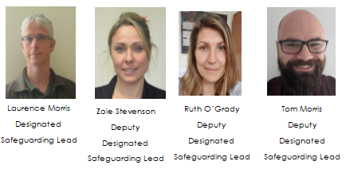

**In addition, Sally Hodges, our Wellbeing Liaison, is available to talk to parents and carers as well as students.**

**Mental Health**

Nip in the Bud have produced a range of videos to help parents and carers to learn about children’s mental health through film – they can be found here: <https://nipinthebud.org/>

**NSPCC Online Safety**

There’s loads of useful information on this site:

<https://www.nspcc.org.uk/keeping-children-safe/online-safety>

**Safer Internet Centre**

Another site with a range of reliable information for parents and carers:

<https://saferinternet.org.uk/guide-and-resource/parents-and-carers>

**Family Agreement**

A family agreement is a great way to start a conversation with your whole family about how you all use the internet, and to start discussions together around how to behave in a positive way when online, whether this is at home, at school or at a friend’s.

<https://www.childnet.com/resources/family-agreement/>

**Guide to Monitoring apps**

With children accessing the internet on a range of devices, the job of protecting them from things they may not be ready for online can be a challenge.

In recent years, a wide variety of monitoring software solutions have appeared to allow you to see what children are doing online and set digital boundaries. Internet Matters have a guide to how monitoring apps can help:

<https://www.internetmatters.org/resources/monitoring-apps-parents-guide/>

**Gaming Safely**

SWGfL have useful advice about how to stay safe whilst gaming:

<https://swgfl.org.uk/topics/gaming/>

**Safeguarding and promoting the welfare of children is everyone’s responsibility. Everyone who comes into contact with children and their families has a role to play.**

**Keeping Children Safe in Education 2024**