**Privacy Notice**

**for Pupils**

**​**

**The Haven School**

**​**

**​**

​****

​

​

​

​

​

​

​

​

​

​

​

|  |  |  |
| --- | --- | --- |
| **​Approved by:** | ​ Zoie Stevenson | **​Date:**   July 2024 |
| **​Last reviewed on:** | ​ December 2024 | |
| **​Next review due by:** | ​ December 2025 | |

**​​**

**Document Owner and Approval**

Haven School is the owner of this document and is responsible for ensuring that this policy document is reviewed in line with School’s policy review schedule.

A current version of this document is available to all members of staff in The Haven Hub.

Signature: Date:

**Change History Record**

|  |  |  |
| --- | --- | --- |
| **Version** | **Description of Change** | **Date of Policy Update** |
| **1** | **Initial Issue** | **July 2024** |
| **2** | **Formatting** | **December 2024** |

**What is Personal Data?**

Personal data is information about you. This is information that could potentially identify you. This includes your name, your date of birth, your address and phone number.

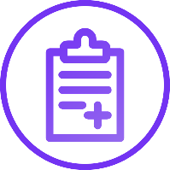

**What Personal Data does School Collect?**

Your information, including your name, address and date of birth;

Your school grades and records;

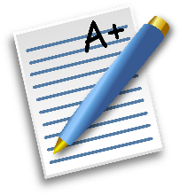Safeguarding information;

Medical information;

Attendance records;

Photographs

Information about your homelife.

**Why does School need this Information?**

We have a duty of care under the law to you. The law states that we need this information to know who is attending the school and to provide you with an education.

It is important for the school to keep you safe and hold this information to enable us to do this.

**Who does School Share Your Data With?**

It is important for us to share some of this information with the police, the NHS and exam boards.

We must also share this information with the local authority.

We share information with other schools and colleges you may wish to attend.

**Where does School Keep this Data?**

We keep this data within the school, in a large manner of ways. This could be in files under lock and key or on a computer with strong security.

**How long does the school keep this data for?**

We often review our files to ensure we are only holding the documents we need. Once you leave the school, we may be required to keep some information about you.

**Any questions, please contact Mrs Stevenson or Mr L Morris or the school’s data protection officer, Judicium Education at dataservices@judicium.com.**